COME JOIN THE 2018 WORLD’S LARGEST
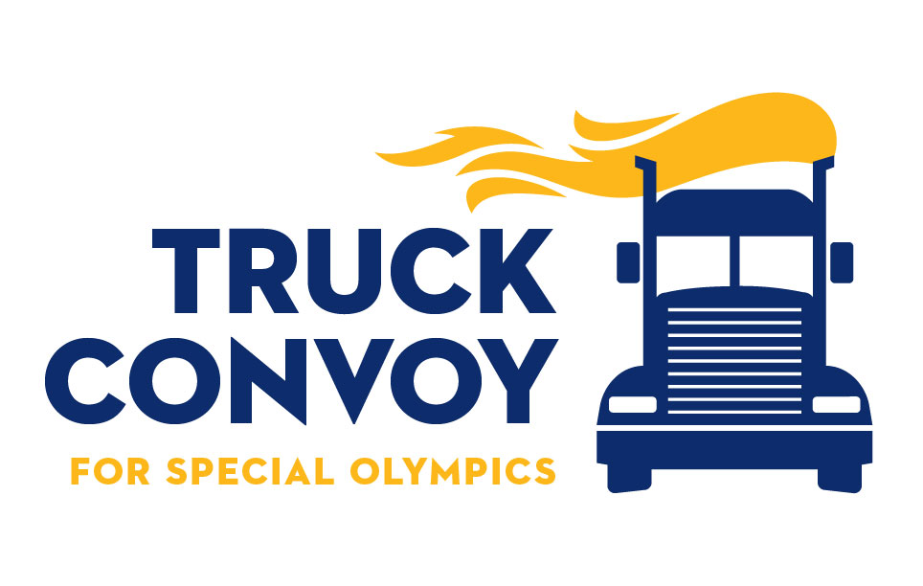
Sept. 29, 2018
8 AM Registration – 10 AM Roll Out!
South Carolina State Farmers Market
3483 Charleston Hwy.
West Columbia, S.C. 29172

REGISTRATION PACKET

On Saturday, September 29, 2018, join the compassionate army of truck drivers, as law enforcement officers escort the World’s Largest Truck Convoy® across the highways and byways of South Carolina to raise awareness and funds for Special Olympics athletes and change attitudes toward people with intellectual disabilities.
The Truck Convoy® is a national celebration of the trucking industry and its support of Special Olympics.
Truckers will meet at the grounds of the South Carolina State Farmers Market, and will be escorted North then back South, on I-77 in Columbia. On return to the State Farmers Market, they are welcomed by the Special Olympics community - athletes, families, friends, colleagues, law enforcement officers and the organizations, companies and agencies that make up the trucking industry. A lunch celebration and activities will be followed by an awards ceremony held to recognize participating truckers and their support of the trucking industry. Whichever form the celebration takes, the message is the same: “Thank you for your support of Special Olympics athletes and for keeping our communities moving!”
Families of all participants are welcome to share in the celebration and free lunch!
Inspired by the powerful impact Special Olympics had on his life through his participation in the Law Enforcement Torch Run®, combined with his job duties as a State Transport Police officer and love and respect for the trucking industry, Mike Still, a Sergeant with the SC State Transport Police, organized the Truck Convoy, a one-day celebration of the trucking industry to help raise awareness and funds for Special Olympics South Carolina.

Mike has retired from the SC Transport Police and is now the Safety Director for The SEFA Group. He has been joined by many friends and family who volunteer their time and resources, to help plan, organize and fund this event.
Vehicle Types Allowed:
Semi-trucks, truck/trailer combinations, large trucks, low-boys, dump trucks, flat beds, buses, large tow trucks, large box trucks, etc. All trucks entering the convoy must be of 10-GVW or larger.
Address:
South Carolina State Farmers Market
3483 Charleston Hwy.
West Columbia, S.C. 29172
The Lead Truck will be determined the day of the Convoy.
The company or driver that raises the most money will get this honor.
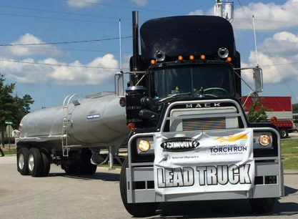
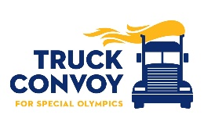

PROGRAM OF EVENTS
8:00 AM - Registration Opens / Silent Auctions Begin
9:30 AM - Mandatory Driver’s Meeting
10:00 AM - Convoy Rolls Out!!
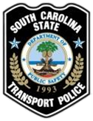
After the Convoy returns to the Farmer’s Market, activities include:
- Lunch
- Live DJ
- Dunk-A-Cop dunking booth
- Games
- Jump Castle for kids
- Massages (From the Southeastern Institute Massage School)
- Antique Truckshow
- Silent Auctions & 50/50 Raffle
- Awards Ceremony

We are very excited again this year to also have an antique truck show along with the World’s Largest Truck Convoy for Special Olympics. The American Truck Historical Society, Palmetto Upstate Chapter has supported and participated in the WLTC for Special Olympics several years now. The ATHS will also be joined by the Antique Truck Club of America Palmetto Iron Classic Chapter. ATHS and ATCA will display their incredibly beautiful antique trucks and tractors for convoy participants and guests to enjoy. If you are a truck enthusiast or have your own antique or show truck, you can join in the fun with them. Reserve your spot by contacting Phil Hyrnerko at 803-960-2528.
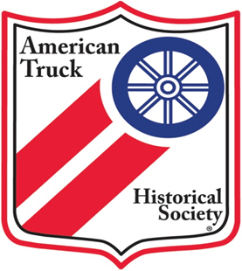

SPONSORSHIP LEVELS
Guardian Sponsor - $2500 donation allows:
- Up to 20 entries in the convoy, one of which will be designated to be in the top five or tail five. (First come, first serve).
- Company name or logo displayed at the event.
- Lunch for corporate representative and/or participating drivers.
- Personal invitation to press conference and presentation of your company’s contributions.
- Opportunity to have company message read at the awards ceremony
Gold Sponsor - $1000 donation allows:
- Up to 10 entries in the convoy.
- Company name or logo displayed at the event.
- Lunch for corporate representative and/or participating drivers.
- Personal invitation to press conference and presentation of your company’s contributions.
Silver Sponsor - $500 donation allows:
- Up to 5 entries in the convoy.
- Company name or logo displayed at the event.
- Lunch for corporate representative and/or participating drivers.
- Personal invitation to press conference and presentation of your company’s contributions.
Convoy Participant / Individual Donation - $100 donation allows:
- One truck entry in the convoy
- Lunch provided for the driver
Vendor / Info Table - $100 donation allows:
- One lunch provided (donation for others)
- One table spot in the shed (bring your own table) or one spot in the vendor area
Lead Truck:
- Drivers and companies can raise funds to be the “Lead Truck” in the convoy (A great honor). It is very easy; just create your own fundraising page on Firstgiving.com. Email or post it on social media to family, friends and coworkers and ask them to donate to you. The top fundraiser will get to be the lead truck and the second highest gets rights to be the final truck. You can create your page here:
https://www.firstgiving.com/so-sc/2018-truck-convoy

REGISTRATION FORM

Please remember to include proof of insurance with this registration form.
Sponsorship Level
I, or my company, wish to participate as:
· Guardian Sponsor - $2,500 (No. of trucks: ____) Gold Sponsor - $1,000 (No. of trucks: __)
· Silver Sponsor - $500 (No. of trucks: ____) Convoy Participant - $100______)

Company Information
Please list main company contact information in this section. The next page of this form should be completed and signed by each driver.
Company: ______________________________ Contact Name:__________________________
Address: _______________________________ Email: _______________________________
City: __________________________________
State:_______ Zip Code: ____________
Phone: (_____)________________ Fax :(_____)_______________________
Method of PAYMENT:
Total Amount Due: US $ ________________________
Check enclosed made payable to Special Olympics South Carolina

Charge to: Visa MasterCard AmX Discover
Acct#:_____________________________________ Exp. Date: ___/____ Code_____
Card Holder Name: _____________________________________________
Signature: ___________________________________________________

REGISTRATION AND PAYMENT ALSO ACCEPTED THE DAY OF THE CONVOY, BUT WE CAN PLAN BETTER IF YOU SEND IT IN ADVANCE - THANK YOU!

Please remember to include proof of insurance with this registration form.

Please make all checks payable to Special Olympics SC and return these 2 pages with your check to:
Special Olympics South Carolina
Attn: Truck Convoy
109 Oak Park Dr.
Irmo, SC 29063
Driver Information:
Please submit the following information for each driver participating in the Truck Convoy.
Each driver must verify that the following information is true and accurate. Make additional copies of this sheet as needed.
Company: _________________________________________________________________
Driver Name: ______________________________________________________________
Address: __________________________________________________________________
City: ____________________________________St: _______________________________
Zip: ___________________E-mail: _______________________@____________________
______I have a minimum of $1,000,000 combined single limit insurance for my vehicle
______I have the minimum insurance limits required in the above named state
______I have a Commercial Driver’s License.
By signing below, I certify that the information I have provided on this form is true and accurate to the best of my knowledge.
Driver Signature______________________________________________________________
Date_______/___________/_2018________
PLEASE SUBMIT THESE 2 PAGES ALONG WITH YOUR PAYMENT!
ANY QUESTIONS CONTACT:
Mike Still – (803)530-1791 Stephen Carter – (864)993-3941
Tim Cooley – (864)921-6202 Rusty Moss – (864)303-9002

